3.22 View Community Flood Reports
Function trigger:
- Navigation path: Citizen App > Community Reports / Map View
- Timing Frequency: On demand (User-triggered) or Auto-refresh when viewing map
Function description:
- Actors/Roles: Moderator, Citizen
- Purpose: Enable citizens to view flood reports from other community members to stay informed about flood situations in their area. Supports situational awareness and helps authorities communicate flood risks effectively.
- Interface:
  - List View:
Table of community flood reports showing:

- Report ID / Reference Number
- Location (address or distance from user)
- Submission Date/Time
- Severity Level (Thấp, Trung bình, Cao)
- Description excerpt
- Media thumbnail (if available)
- Vote count (upvotes/downvotes)

  - Filter Controls:
- Time range selector (Last 1h, 6h, 24h, 48h, 7 days)
- Severity filter (All, Low, Medium, High)
- Map bounds (auto-filter by visible area)

  - Actions:
- View Report Details
- View All Media Attachments
- Get Directions to Report Location
- Filter by Time Range
- Filter by Severity Level
- Refresh Report List

Data processing:
- The user navigates to the Community Reports screen or opens map view.
- The system queries the `flood_reports` table with the following filters:
- Status = 'Published'
- Score >= visibilityThreshold (default: 0)
- CreatedAt >= fromTime (default: last 24 hours)
- Latitude/Longitude within bounds (if provided)
- The system returns paginated results sorted by newest first.
- For Map View: The system clusters nearby reports to improve performance.
- For List View: The system displays reports in table format with pagination.
- Create/Update: N/A (read-only feature)
- Delete: N/A (read-only feature)
Screen layout:

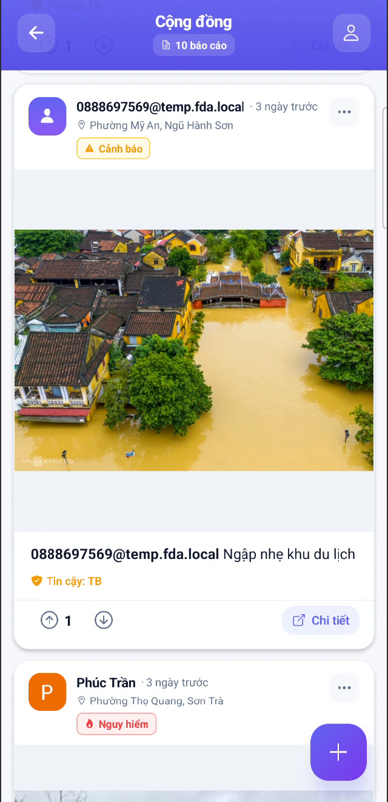
Figure 60: View Community Flood Reports
Function details:
- Data:
- flood_reports table: ID, User ID, Latitude, Longitude, Address, Description, Severity, Status, Score, Created At
- flood_report_media table: ID, Report ID, Media Type, Media URL, Thumbnail URL

- Validation:
- User must be authenticated
- Bounds must be valid coordinates
- fromHours must be positive integer
- page must be >= 1
- pageSize must be <= 100

- Business Rules:
- Hidden reports (marked by FE-25/FE-27) must never be returned
- Reports with status other than 'Published' are excluded
- Reports with score below threshold are excluded
- Maximum 100 reports returned per page

- Normal Case: Citizen opens the app and navigates to Community Reports. System displays map with recent flood reports from the community. User taps on a report marker to see details. User can switch to list view to see more reports in table format. User filters by "Last 24 hours" to see only recent reports.

- Abnormal Case:
1. No reports in area: System displays "No flood reports in this area. Be the first to report!"
2. All reports hidden: System displays "No visible reports in this area."
3. Invalid bounds parameters: System ignores invalid bounds and returns default area reports.
4. Network error: System displays "Unable to load reports. Please check your connection." with retry button.
5. Authentication expired: System redirects to login screen.
6. Too many reports (clustering): System clusters reports and shows count badge. User taps cluster to zoom in.

